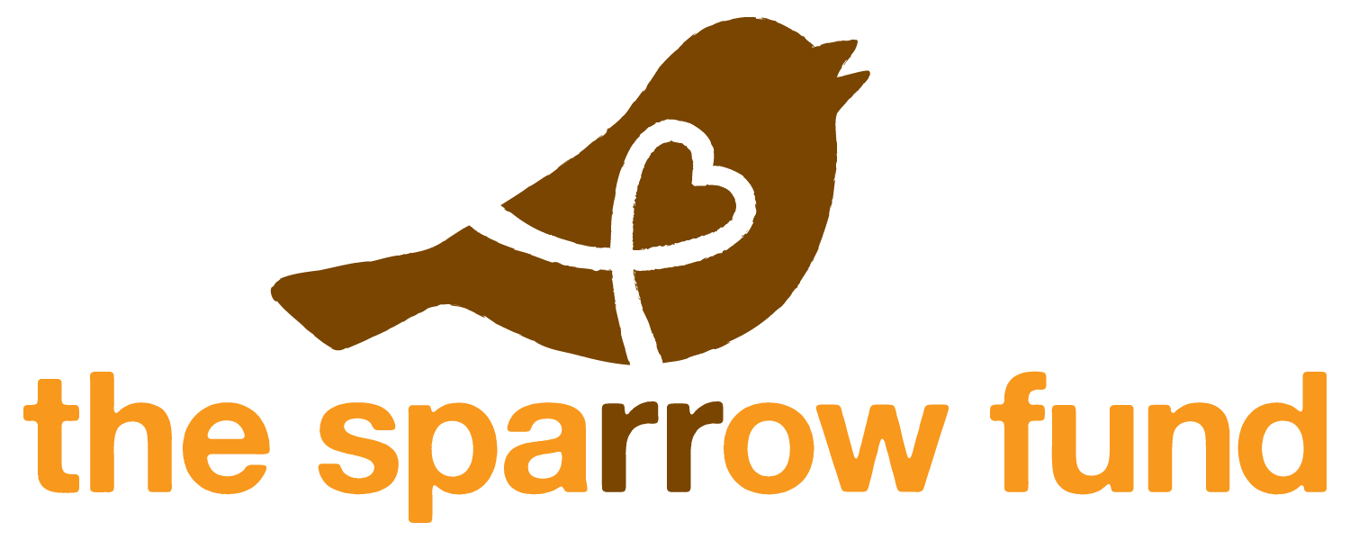

The Sparrow Fund is committed to encouraging and supporting families as they prepare for the adventure of adoption. We do this by providing regular training opportunities as well as grants to families in financial need to enroll in programs specifically designed to provide counsel and comprehensive medical reviews of their referred child.

We are excited to now be offering a way to help families fundraising to offset the costs of their adoptions through selling Kenyan jewelry.

Here’s how it works:
- You decide what pieces you want to sell—bags, wire wrap bracelets, necklaces, or earrings—and complete the order form. Examples of pieces can be seen at www.thesparrowfund.etsy.com, but we will select a variety of pieces for you.
- Email the signed and completed form to fundraising@sparrow-fund.org with “Kenyan Jewelry Adoption Fundraiser” as the subject line. We will send you a PayPal invoice for the total amount including a nonrefundable $20 administrative cost which covers our paypal transaction fee as well as the cost of informational cards and the shipping to you. (Please note that we are not making money off of this fee. We are keeping it as low as we possibly can to break even.)
- Once paid, we will send you the pieces you have selected along with information cards to give out with each item sold which tell about the women who make the jewelry and allow a place for you to tell people the sales support your adoption.
- Sell the pieces for 90 days. All money made on sales are yours to use to offset adoption costs! The adoptive moms in Kenya are supported, and your adoptive family is supported!

Guidelines:
- All money made must be used for direct adoption costs.
- All sales prices are fixed, meaning you must sell at a specific price.
Item | Cost to you | Amount it must be sold for | Your profit per item
Bracelets | $8.00 | $15.00 | $7.00
Necklaces | $8.00 | $15.00 | $7.00
Earrings | $3.00 | $6.00 | $3.00

- You can sell the items in person (be creative! Get a table at a craft fair, have a jewelry party, a women’s tea, or youth group event) or online via Facebook, Twitter, blogs, or other social networking sites. However, you cannot sell the jewelry on Etsy. It breaks rules set up by Etsy that we are committed to following.
- An information card must be given to the buyer with each item sold.
- Return any/all unsold, unworn pieces for a refund for each piece within 90 days of the original shipment date. You are responsible for the shipping cost back to: The Sparrow Fund, 124 Third Ave., Phoenixville, PA 19460. The refund will be given from the original PayPal payment.
- Jewelry may be sold only up until your child comes into your home. We do not promote selling for fundraising when you are home adjusting to a new child.
- We reserve the right to limit the number of fundraising families at any given time. We also reserve the right to adjust the pricing as needed due to exchange rates or increased administrative costs.

Order Form

Parents’ Names |  | Adoption Agency
Email address for correspondence |  | Type of Adoption  (China, Ethiopia, Domestic, etc.)
Email address to use for PayPal invoice |  | Blog address (if applicable)

Address 1
Address 2
City
State |  | Zip Code

Item | Quantity | Wholesale Price  Per Item | Cost
Bracelets |  | $8.00 | $
Necklaces |  | $8.00 | $
Earrings |  | $3.00 | $

Subtotal | $
Nonrefundable Administrative Cost | $22.00
Total Due | $

I agree to the rules set forth by The Sparrow Fund and agree to all the guidelines described in this document.

Name

Signature Date

